IMPORTANT SITE INFORMATION
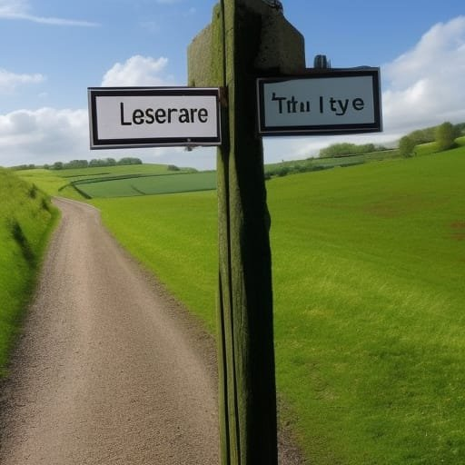
Site Navigation
This site is expressed in a way that can allow you to find articles of interest by 'following' images you learn to associate with a subject or product type. * THE END * I hope you enjoyed your time here, with me, Scott, aka Elitelixir *
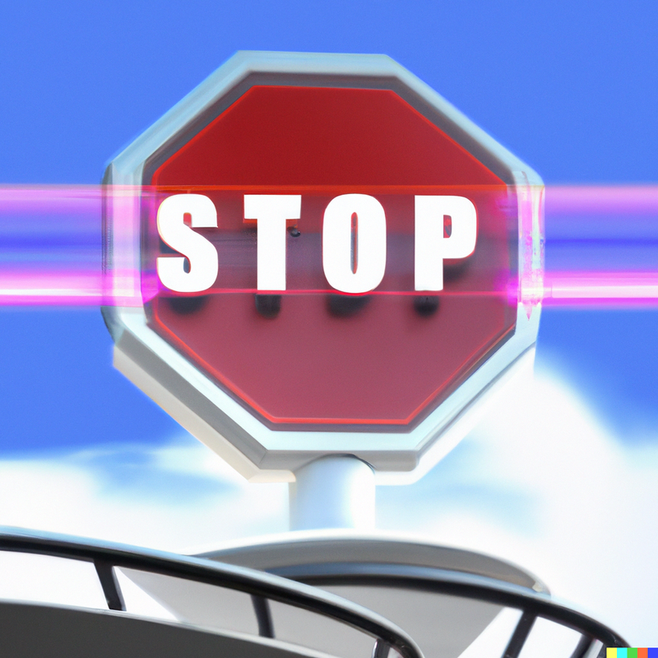

IMPORTANT SITE INFORMATION
Important Site Information At Elitelixir's Mag: :Recreation Within, I strive to create an enjoyable and entertaining experience for my readers. However, I understand that certain content may be sensitive or potentially triggering for some individuals. To ensure a safe and respectful environment, I provide the following warnings and trigger warnings:

Content Warning: Violence Some articles or stories within this magazine may depict or discuss violent acts or contain descriptions that could be unsettling. Reader discretion is advised.
Trigger Warning: Trauma and Abuse Certain articles or stories may touch upon topics such as trauma, abuse, or related experiences. I recognize the potential impact these subjects can have on individuals, and encourage readers to approach such content with caution or choose to skip it if necessary.
Content Warning: Strong Language This magazine may include the occasional use of strong language. While I aim to maintain a balance between entertainment and respect, I acknowledge that some readers may find explicit language uncomfortable.
Trigger Warning: Mental Health and Psychological Themes Some articles or stories may explore themes related to mental health, including anxiety, depression, or other psychological conditions. I recognize the importance of sensitivity and understanding when discussing these topics.
Content Warning: Sexual References Certain articles or stories may contain sexual references, preferences or discussions. I aim to handle these topics with respect and tastefulness, but readers who may find such content uncomfortable are advised to exercise caution.
Trigger Warning: Loss and Grief Some articles or stories may touch upon themes of loss, grief, or mourning. I understand the emotional impact these topics can have and encourage readers to consider their own well-being before engaging with such content. Content Warning: Substance Abuse Occasionally, articles or stories may depict or discuss substance abuse or addiction-related topics. I acknowledge the potential sensitivity of these subjects

and encourage readers to approach them thoughtfully. Please note that these warnings are intended to provide a general guideline, but individual experiences and sensitivities may vary. I encourage readers to prioritise their well-being and make informed choices when engaging with my content. If you require further assistance or have specific concerns, please reach out to me Disclaimer: The warnings and trigger warnings provided are for informational purposes only and do not encompass all potential sensitivities or triggers. They are intended as a general guideline to promote a safe and respectful reading experience. Readers are encouraged to take personal responsibility for their well-being and make informed choices based on their individual needs and sensitivities.



Fictional Content Notices
It is important to note some content within this magazine is fictional and created solely for entertainment and/ or educational purposes. Any resemblance to real individuals, events, or places in these fictional (and mainly satirical or amusing or a mixture of both) instances is entirely for entertainment and/ or educational purposes. Fictional Content: Some articles, stories, characters, and events depicted within Elitelixir's Mag: :Recreation Within, are entirely fictional. They are the product of creative imagination and should not be interpreted as reflecting real-life situations or individuals.

Imaginary Characters: Some characters portrayed in this magazine are products of my creativity. Any similarities to real people, living or deceased, are purely coincidental. I aim to create lively and engaging characters that bring stories to life while maintaining the understanding that they are fictional entities.
Creative Licence: I employ creative licence to craft entertaining narratives and explore various themes. This means that certain aspects of stories may deviate from reality or take artistic liberties for the sake of storytelling.
Editorial Discretion: I take great care in curating content to ensure an entertaining and inclusive experience for my readers. I review all materials to maintain quality and adhere to ethical guidelines. However, I acknowledge that individual interpretations may vary, and opinions expressed within articles or stories do not necessarily reflect those of me, Elitelixir's Mag: :Recreation Within'S author.
Copyright and Intellectual Property: The content within Elitelixir's Mag: :Recreation Within, including articles, stories, illustrations, and photographs, is protected by copyright laws. Unauthorised reproduction or distribution of any materials from this magazine is strictly prohibited.
Reader Responsibility: While I strive to create a safe and enjoyable reading experience, I encourage readers to exercise personal responsibility and discretion. If any content within Elitelixir's Mag: :Recreation Within is found to be offensive, triggering, or inappropriate, please contact me immediately so that I may address the issue promptly.
Please note that this disclaimer is intended to clarify the fictional nature of my content and provide transparency to my readers. I appreciate your understanding and support as I continue to entertain and engage my audience through imaginative storytelling.

Disclaimer: The information provided in this section is for informational purposes only and does not constitute legal or professional advice. The guidelines and disclaimers outlined above are subject to change without notice. Please refer to my Terms of Use and Privacy Policy for further information.



Terms of Use
By accessing and using Elitelixir's Mag: :Recreation Within, you agree to abide by the following Terms of Use. Please read these terms carefully before proceeding. If you do not agree with any part of these terms, please refrain from using our website or engaging with Elitelixir's Mag: :Recreation Within's content
Intellectual Property All content on Elitelixir's Mag: :Recreation Within, including articles, stories, images, graphics, logos, and trademarks, is protected by intellectual property laws and is the sole property of Scott, aka Elitelixir, and contributors. Unauthorised use,

reproduction, or distribution of any materials from this website is strictly prohibited.
Use of Content You may view, read, and interact with the content on Elitelixir's Mag: :Recreation Within for personal, non-commercial purposes only. You may not modify, reproduce, distribute, or exploit the content in any way without explicit permission from Scott, aka Elitelixir.
Accuracy of Information While I strive to provide accurate and up-to-date information, I cannot guarantee the accuracy, completeness, or reliability of any content on my website. The information provided is for entertainment purposes only and should not be relied upon as professional or factual advice.
Third-Party Links This website may contain links to third-party websites or resources that are not controlled or endorsed by me. I am not responsible for the content or practices of these external websites, and accessing them is done at your own risk.
User-generated Content Any user-generated content, such as comments or contributions, provided on Elitelixir's Mag: :Recreation Within is subject to review and moderation by Scott, aka Elitelixir. I reserve the right to remove or modify any content that violates our guidelines or terms of use.
Disclaimer of Liability In no event shall I, or contributors, be liable for any direct, indirect, incidental, special, or consequential damages arising out of the use or inability to use this website or content. This includes, but is not limited to, damages for loss of profits, data, or other intangible losses.
Privacy I take user privacy seriously. Please refer to my Privacy Policy for information on how I collect, use, and protect your personal data. Changes to Terms I reserve the right to

modify or update these Terms of Use at any time without prior notice. By continuing to use this website, you accept any revised terms. If you have any questions or concerns regarding these Terms of Use, please contact Scott, aka Elitelixir.

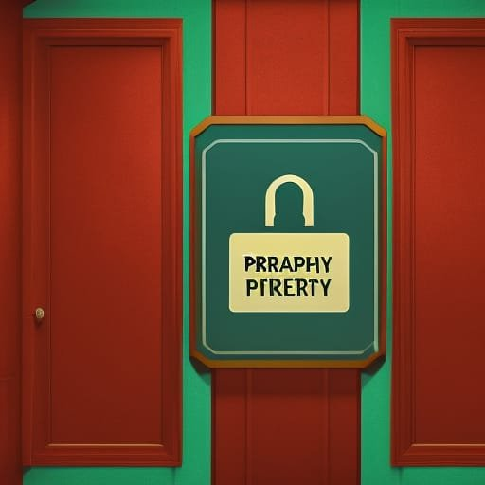

Privacy Policy
This Privacy Policy governs the manner in which this site collects, uses, maintains, and discloses information collected from users (referred to as "User" or "you") of the Elitelixir's Mag: :Recreation Within website. This policy applies to the website and all products and services offered by Elitelixir's Mag: :Recreation Within, now and in the future.
Information Collected This site may collect personal identification information from Users in various ways, including but not limited to when Users visit this website, register on the site, subscribe to any future newsletter, respond to a survey, or fill out a form. The

information collected may include: Name and contact information (such as email address)
Demographic information Other information relevant to user surveys and/or offers How Information May Be Collected This site may collect Users' personal information for the following purposes:
To improve this website: I continually strive to improve this website's offerings based on the feedback and information I receive from you.
To send periodic emails: I may use the email address provided to send User information and updates pertaining to their subscription, order, or other requests.
To personalise the user experience: I may use the information to understand how our Users as a group use the services and resources provided on this website. How I Protect Your Information I adopt appropriate data collection, storage, and processing practices, as well as security measures, to protect against unauthorised access, alteration, disclosure, or destruction of your personal information, username, password, transaction information, and data stored on this site.
Sharing Your Personal Information I do not sell, trade, or rent Users' personal identification information to others. Third-Party Websites Users may find advertising or other content on this website that links to the sites and services of third parties. I do not control the content or links that appear on these sites and I am not responsible for the practices employed by websites linked to or from this site. Browsing and interaction on any other website, including websites that have a link to this site, is subject to that website's own terms and policies.

Changes to This Privacy Policy I have the discretion to update this Privacy Policy at any time. I encourage Users to frequently check this page for any changes to stay informed about how I am helping to protect any personal information collected. You acknowledge and agree that it is your responsibility to review this Privacy Policy periodically and become aware of modifications. Your Acceptance of These Terms By using this website, you signify your acceptance of this Privacy Policy. If you do not agree with this policy, please do not use this website. Your continued use of this website following the posting of changes to this policy will be deemed your acceptance of those changes. If you have any questions about this Privacy Policy, the practices of this site, or your dealings with this site, please contact Scott, aka Elitelixir.



Copyright Notice
All content published on this site is protected by copyright laws and is the exclusive property of Scott, aka Elitelixir, and contributors. No part of this magazine may be reproduced, distributed, or transmitted in any form or by any means without the prior written permission of the copyright owner.
The copyright extends to all articles, stories, images, graphics, logos, and trademarks within this site. Unauthorised use, reproduction, or distribution of any materials from this magazine is strictly prohibited and may result in legal action.
By submitting any content to me, you acknowledge and agree that you are granting me and my affiliated entities a non-exclusive, royalty-free, perpetual, and worldwide licence to use, publish, reproduce, modify, adapt, distribute, and display the content in any media.

If you believe that your copyrighted work has been used on this site without authorization, please contact me immediately with the following details: Identification of the copyrighted work claimed to have been infringed. Description of the infringing material and its location within this site. Your contact information, including name, address, phone number, and email address. A statement by you, made under penalty of perjury, that the above information is accurate and that you are the copyright owner or authorised to act on behalf of the copyright owner.
I respect the intellectual property rights of others and will promptly investigate any claims of copyright infringement brought to my attention.

